

Term 2 Primary 4

Time 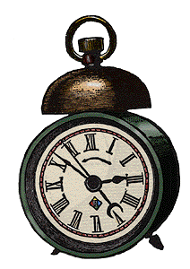

- Ask your child the time focusing on five minute intervals e.g. five past three, ten past, twenty past, twenty five past, five to, ten to, twenty to, twenty five to.
- Time how long it takes to do their homework and maybe set a time for completion of a task.
- Encourage use of the calendar to record dates. Count the number of days or weeks until important dates.

We use these good websites in school for time.

www.teachingtime.co.uk
www.ladybird.co.ukwww.time-for-time.com/swf/myclox.swf

Length 

- Measure the heights of family members and record this.
- If at swimming pool draw attention to length of pool and depths e.g. 1m deep, 2m deep.
- Provide rulers and measuring tapes to allow your child to investigate lengths independently.

Money 

- When going to the shops ask your child to buy something for less than 50p and work out the change from 50p and then repeat for change from £1.
- Understand what coins could make up 50p or £1.
- Ask your child to make 50p or £1 in different ways.
- Assist your child in the counting of money in a money box.
- Encourage your child to mentally add totals within £1.

We use this good website in school for money.

www.topmarks.co.uk/interactive

Shape and Space

- Draw attention to the various shapes of Easter eggs, boxes, tins etc.
- Observe that each half of an Easter egg is identical to the other half ( symmetry)
- Encourage children to complete symmetrical patterns (can be found in colouring books, etc).
- Use game boards such as draughts to give directions to reach given targets.
- Games such as Battleship are excellent at encouraging awareness of space and direction.
We use this good website in school for shape and space.

www.primaryresources.co.uk/maths

Number 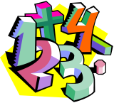

- Using their number grids help your child count in 3’s and 4’s e.g. 3,6,9,12…. 4,8,12,16 etc
- Help your child to recall 2, 3, 4, 5 and 10 times tables.
- Encourage your child to complete number sequences starting from random numbers and going up/ down in 2, 3, 5 or 10’s.
- Continue to draw attention to fractions in practical examples, 2 halves of a game, dividing a cake into 6 pieces, etc.

We use these good websites in school for number.

www.bbc.co.uk/schools/websites
www.teachingandlearningresources.co.uk/funmaths

